RHETORIC VERSUS REALITY OF POSTMODERNISM IN MATHEMATICS EDUCATION:
The Challenges of Implementing a Learner Centred Pedagogy in Botswana General Certificate of Secondary Education Mathematics Curriculum

Alfred Bhusumane & Alakanani A. Nkhwalume

University of Botswana
nkhwalumeaa@ub.ac.bw

ABSTRACT

This study endeavoured to unravel the reality of the envisaged learner-centred mathematics pedagogy as against the rhetoric that the curriculum developers espoused. This is on the backdrop of postmodernist pronouncements on the mathematics syllabus whose rationale stated that:

To achieve the stated aims and objectives the teaching and learning of Mathematics is to be based on a learner centred approach. A variety of methods are therefore to be used such as exposition and consolidation, discussions, practical work, problem solving activities and investigative work. Furthermore teaching and learning of mathematics should utilise modern technology such as the graphic calculators and computers that place mathematics in a realistic context. This will offer a constructivist view on mathematics to learners, promote interest and motivation, and prepare the students effectively for the next century paving the way for future generations.

The research purported to find out whether the implementation of the mathematics syllabus was successful given the declining or stagnant results for the past five years. The learner-centred instructional implementation was meant to give learners more autonomy and the liberty to construct their own knowledge and hence improve instructional outcomes. However, the study has revealed the prevalence of poor performance in mathematics resulting from teacher-centred instructional methodologies.

The study considered issues of curriculum implementation processes, the concept of learner-centeredness and teachers’ readiness to engage in syllabus implementation given their current training and in-service professional development which was reflected to be at stalemate

Key words: postmodernism, curriculum implementation, mathematics syllabus, rhetoric and reality, learner-centred

Introduction
There have been significant changes in the mathematics curriculum aimed at improving teaching and learning over the past few years. Because of observed poor results most mathematics curricula have been focused on developing student knowledge through learner’s discoveries and experiences during instructions. The learner centred method has been under development from the 1950s. I started as a person-centred education and then later converted to learner-centred education in 1990s (Cornelius-White, 2007). The person-centred education was more concerned with teacher empathy, on-directivity and encouragement of critical thinking. The learner cantered method focuses on all the learning domains (Cornelius-White, 2007:.113-115). In trying to make sense of the insights of these divergent perspectives of social reality and its existence, it is worth to establish the merits and limitations of considering the students in our classrooms as only collections of individual minds, in contrast with perspectives that posit the primacy of the social in determining the identity of mathematics learners. In the learner centred model, learners learn mathematics by doing to create discoveries; learners are an active part in the acquisition of their own mathematical knowledge (Flores,2010).The method is based on the pragmatic basis of “hands on” mathematics where learners are mathematical apprentices that learn applying their knowledge in a workshop form (Flores,2010). Recent developments in analytical social theory may have the potential to address this issue productively (Kent, 2014). This study is well characterised by revealing the conflicting fact between rhetoric and reality of the postmodernist perspectives in mathematics education. This attracts literature and the critical role of inter-subjectivity in communicating mathematics through interaction and exploring through project method.
After several decades of the Mathematics education policy rhetoric in Botswana, the discipline of mathematics continues to be used for social stratification. Learners are often tracked or “sorted” per their perceived mathematics “abilities” (Stinson and Bullock, 2012).This (perceived) ability tracking continues to be a fundamental aspect of mathematics education despite research showing the positive possibilities of de-tracked mathematics classrooms (Boaler and Staples 2008).Most mathematical classes are influenced by Platonic Ideal: either a child possesses the aristocratic characteristic of intelligence or not, and those who do “should persist in their studies until they reach the level of pure thought, where they will be able to contemplate the very nature of number” (Plato,1996: 219). This discursive practice of linking (perceived) mathematics ability to intelligence, and thus to power and privilege, continues to permeate Western ideology (Foucault, 1972).
This linkage can be described as ‘psychological brutality,’ indicating the reproductive stratifying strategies of schools that lay down final judgments with no appeal, ‘ranking all students in a unique hierarchy of forms of excellence, nowadays dominated by a single discipline, mathematics’, (Stinson and Bullock 2012). Here, to point the way to a mathematics education that might be more ethical and just, a case is made for considering postmodern theory (PT) in mathematics education. It is worth considering that that PT provides a means to make visible the Trojan Horse of the mathematics for all discourse, which, in turn, motivates different questions about and different possibilities for mathematics teaching and learning. (Stinson and Bullock 2012). Postmodernism rejects any static foundational system of logic, resulting in poor mathematics outcomest, therefore this study aimed at unravelling the reality of the envisaged learner-centred mathematics pedagogy as against policy rhetoric.

Background to the study
Botswana is among many African states where formal education was introduced through the works of European Missionaries, notably David Livingstone and Robert Moffatt (NCE-1977:11-19). The then aim was to enable citizens to read, write and be numerate, following the three R’s mnemonic – Read, wRite and aRithmetic borrowed from the West (NCE-1977:11-19). The early senior secondary schools were built through missionary initiatives and some still retain their original status to this day (e.g. Mater Spei College, St. Joseph’s College and Moeding College). This is reflected in the 1977 National Commission on Education (NCE-1977:11-19), which reported that:
For 81 years until 1966, Botswana was the Bechuanaland Protectorate under British rule. Not surprisingly, the institutions and culture of the colonial power were imposed on the country. To some extent, the indigenous culture became submerged and Batswana were coerced to believe that their own cultural inheritance was inferior to that imposed by the British and the education system was developed from models of the developed countries.
Despite a curriculum and syllabus review in 1968 and 1969 and continuing efforts to develop improved curricula, the syllabuses still retain strong traces of their European origins.
This is not surprising since Botswana statesmen of that period advocated for the European style of education given that the local education material was deemed inferior. For instance, during the protectorate period, the then Botswana leadership requested the introduction of the British education system as reflected in Khama the Great’s (1895) plea to the British authorities:
We ask that we may be enabled to give our children that learning which your children get (Quoted in Parsons, 1972:12).

Consequently, the London Missionary Society (LMS), the Roman Catholic Church, the Dutch Reformed Church and other Western religious institutions orchestrated the introduction of Teacher Education in Botswana as Parsons (1984:24) reported:
The first Western-style primary was established by David Livingstone of London Missionary Society (LMS) at Kolobeng in 1847. Further schools were opened in 1857 and 1860 by German Lutheran missionaries and the LMS later added others
Educational concepts, including mathematics as taught in Botswana today, evolved from these ‘borrowed’ Western curricula, from the United Kingdom and it is possible to speculate that learners have since regarded mathematics as another foreign language such as English.
In line with their historic establishments, senior secondary schools in Botswana have been offering the Cambridge Overseas School Certificate (COSC) before independence in 1966. Initially everybody had to do mathematics with emphasis on arithmetic as the practical needs of society then underpinned the philosophy of learning.
Later there was a shift of emphasis to abstract mathematical concepts and at some stage, but for a short period; a ‘Certificate in Mathematics’ course was introduced at senior secondary level for those who could not cope with the core abstract mathematics syllabus. The present mathematics syllabus which inevitably developed from previous revisions of the COSC syllabus has evolved from earlier versions designated as Syllabuses 'A', 'B', 'C' and 'D' respectively. These versions were introduced as and when socio-economic, political and educational philosophical changes took place in the developed world, specifically in the United Kingdom (UK) which was the then colonial power and the United States of America (USA) (Botswana, 1976a:114-118). During the 1970s there were calls to contextualise the curriculum to reflect local socio-economic developments and at the same time maintaining a global image.
The first National Commission on Education (NCE) discussed the localisation of the Cambridge examinations in some detail (Botswana, 1976a:114-118). It concluded that if Botswana continued to allow the assessment of its education system to be controlled from outside, the curriculum objectives set within Botswana would never be realised. A Botswana Certificate of Education was proposed which would work initially in conjunction with the Cambridge University Examinations Syndicate (CUES). However, the Commissioners saw no need for the localisation of Mathematics, Science and English since for these subjects “the principles, subject matter and context are international” (Botswana, 1976a:116). The ‘Task Force on Secondary Science’ which had also been set up to report to the Commission drew a similar conclusion:
The syllabuses of the science subjects of the Cambridge Board satisfy and are relevant to the needs of Botswana (Botswana, 1976b:5-45).
To secure the necessary control over the examination process, the Commission recommended the establishment of a National Testing Centre as part of the proposed Curriculum Development and Testing Unit. To provide direction and independent oversight of examination policy, maintenance of standards and marking, a Botswana National Examination Council (BNEC) was proposed with “representation from the Ministry of Education, University and possibly secondary schools, teachers unions and other institutions” (Botswana, 1976a:115).
An Examination Unit under the Department of Curriculum Development and Evaluation was eventually set up to administer the examinations on behalf of the CUES but at that point no National Examinations Council was established.
The issue of localisation of the Form Five examinations was re-considered in the National Development Plan 7, 1991-1997 with a provision for the Ministry of Education to localise the COSC ‘O’ level examination during the plan period.
Apart from considering the basics of the process such as the training of examiners and markers, provision was also made for the establishment of an Examinations Council (Botswana, 1991:346). The 1993 National Commission on Education considered the whole issue of localising the Cambridge examination in detail (Botswana 1994:187-190). The ‘immediate’ preparation of a comprehensive programme of localisation of the examinations to be completely achieved by 2003 was recommended. The setting up of an autonomous National Examinations Council was re-visited and recommended. These recommendations were accepted and became part of the Revised National Policy on Education (RNPE) (Botswana, 1994).
The localisation of the senior secondary school curriculum started in late-1996 with the development of a curriculum blueprint for several subject syllabuses, including those of mathematics and the pure sciences. At the beginning of the 1998 school year the new syllabuses for the Botswana General Certificate of Secondary Education (BGCSE) were introduced into the schools at Form Four level to be examined at the end of the 1999 school year. The mathematics syllabus was tailored in line with the British GCSE and broken into Core and Extension parts with examinations consisting of Papers 1 & 2 (Core) and papers 1, 2 & 3(Extension). Papers 1 and 2 were set to be the same for both groups while Paper 3 was for those who exceled in mathematics. The cohort that set for the core examination only could achieve a maximum of a C grade or less. The syllabus was supposed to have project work on its full implementation, after the training of teachers in project assessment, an undertaking that has never been achieved.
It is imperative for the reader to understand that presently the BGCSE examinations are offered by the Botswana Examination Council (BEC) in collaboration with the CUES. The reader’s attention is also drawn to the fact that the implementation process was to be underpinned by a postmodernist learning approach where learning mathematics was to be more relativistic, reflecting the influence of Postmodernism or social constructivism. The basic idea in postmodern education is that all knowledge is invented or “constructed” in the minds of people, not discovered as modernists would claim.
This learning theory espouses that knowledge; ideas and language are created by people not because they are ‘true’ but because they are useful. The emphasis had shifted to the usefulness of mathematics rather than its nature and philosophical abstractness. Declining performance in mathematics has been an alarming circumstance which is a challenge to teachers and curriculum designers to work sleepless nights in the hope of containing the situation. It has affected the society in a crucial manner such that a less number of learners are motivated to pursue programmes which are mathematics orientated.
This also contributed negatively in most science related careers because they require mathematical background for one to consider enrolling in. These declining results have gone to an extent of influencing how people perceive certain disciplines of life. Culturally, mathematics is considered a male dominated area and lees so for female students because of beliefs of it being difficult and this has impacted negatively towards the attitudes of learners. Alternating teaching strategies came out as a rescue measure to eradicate negative attitudes and improve results.
The methodology had to be structured in such a fashion that would always arouse learners’ interest and motivate their esteem. It is of significant notice to consider postmodern methods to be an important discipline in mathematics because it builds proper background for learners of mathematics. According to Cai (as cited in Anderson, 2009) students need deep mathematical knowledge and general reasoning ability as well as heuristic strategies for solving non-routine problems. It is also necessary to have helpful beliefs and personal attributes for organising and directing their efforts.
Teachers have had many opportunities to build knowledge about teaching problem-solving and using problems as a focus of learning in mathematics, (Anderson, 2009, pp. 401) and this remains a good mathematical foundation which needs to be nurtured with multiple strategies of teaching to draw attitudes of learners. Conceptually, researchers have come up with ‘Realistic postmodern method’ in mathematics education, which makes mathematics to look natural. The method involves learners experimenting and re-inventing mathematics for themselves using realistic problems as a starting point for learning and applying new mathematical ideas.
A well-structured model assists learners and makes them claim the progress of the subject matter put before them as they gain confidence and ground to defend and justify the conclusions attained. “In postmodernism, students’ minds could be torn between two types of knowledge system that the concepts activates-one developed in the traditional mathematics classroom and the other through real world experiences” (Sepeng, 2014, pp. 756). This suggests a clear evolution in the teaching and learning of mathematics aimed at stimulating learner’s performance. It caters for all groups and classes of social beings including gender and age. It also encourages non-gender career choices which are at times influenced by mathematics as a limit of enrolment at tertiary education.
The Department of Mathematics and Science Education (DMSE) through its in-service programme (DMSE-INSET) has been working since 2000 with the Department of Teacher Training and Development (TT&D) to assist teachers and school departments with the implementation of the new subjects’ syllabuses in the classrooms. Feedback provided by Heads of Department (HODs) and visits to schools to discuss in-service issues with mathematics teachers have indicated a good number of perceived constraints to the implementation process.
These include, among others, a lack of time, an overloaded syllabus, inadequate teaching aids, students not well prepared by the junior secondary schools and the syllabus not dovetailing with first year science courses at university level. Many teachers also expressed confusion about the postmodernist (learner-centred) classrooms and some felt that the BGCSE syllabuses remain basically the same as they were under the Cambridge system.
This has meant little or no change with respect to the output, i.e. the level of the learners’ understanding of mathematics does not seem to have been enhanced. This is reflected in the national examination results where mathematics remains at the bottom of the heap year in year out. Other projects such as the Strengthening of Mathematics and Science in Secondary Education (SMASSE) have been piloted in the hope that there will be improvements in mathematics and science achievement, but preliminary results from the evaluation of the project do not indicate any significant changes.

The problem

Figure1: Conceptual factors contributing to the problem

Statement of the Problem
As already alluded to, the present mathematics syllabus requires teachers to adopt a social constructivist teaching approach, which includes problem solving, investigations, process skill development, applications of mathematics in local contexts, project work and course work assessment. These methodologies were and continue to be relatively new to most teachers and are also far removed from the absolutist classroom practices currently prevailing in Botswana (Rowell and Prophet, 1990; Prophet and Rowell, 1991; Prophet, 1995; Tabulawa, 1998, 2002).
There seemed to have an over expectation of teachers to implement the learner-centred teaching methodologies in the classroom despite their lack of knowledge on these methodologies. Teachers continue to frequently ask how learner-centred pedagogies manifest themselves in the classroom and many share a negative perception about postmodern education, which for them is an alien concept far removed from African classrooms where the teacher’s task is best described as “giving out and imparting school knowledge” (Tabulawa, 1997:200). These perceptions and problems seem to have had a serious constraint on the successful implementation of the BGCSE mathematics curriculum with all its underpinning philosophical, epistemological and ontological assumptions on teaching and learning.
General objective
The research study described and analysed both quantitative and qualitative successes and failures of implementing the postmodernist (social constructivist) education curriculum as espoused in the revised BGCSE mathematics syllabus.
The Research Question
To what extent has the envisaged classroom implementation process of the BGCSE mathematics syllabus been achieved considering its postmodernist (social constructivist) learner – centred methodological rhetoric?

The Research Hypothesis

There is significant difference between the implementation of the learner-centred BGCSE mathematics syllabus and student performance thereof.
Independent variable:
Teachers’ teaching effectiveness in learner-centred pedagogies (methods, styles, experiments, pedagogical content knowledge etc.) - Continuous Variable
Dependent variable:
Performance of mathematics by students – Categorical variable
Variables/phenomena of concern in the study
Mathematics Performance
Performance of students in mathematics reveals an overwhelming notion which is worth noting beyond reasonable doubt (Nyroos et al., 2015; Steffe and Ulrich, 2014). Custodians to the aforementioned variable are left amazed due to the unbearable phenomenon (poor performance). The government and other beneficiaries intervene in improving outcomes in mathematics learning. Mathematics Performance indicators are usually seen as numerical measures of achievement that are easy to collect and use. In theory, they can only be derived for things over which you have control, however in practice people don’t have absolute control.
Curriculum implementation determination uses a combination of sensors and mathematical models to collect vector components in the body and inertial reference frames. These components are used in one of several different algorithms to determine the attitude, typically in the form of a quaternion, Euler angles, or a rotation matrix. In general, however, it is regarded as a preparation or readiness for response.
Null Hypothesis
There is no significant difference between the implementation of the learner-centred BGCSE mathematics syllabus and student performance thereof.
The Pearson Product Moment Correlation Coefficient will be used for hypothesis testing. According to (Kenny, 2014) a correlation coefficient is a measure of the degree of relationship between two variables; it can vary between -1.00 and +1.00. The stronger the relationship between the variables, the closer the coefficient is to either -1.00 or +1.00. The weaker the relationship between the variables, the closer the coefficient is to 0. (p.142). The null hypotheses will be tested at the probability level of .05 (α =.05), that is the amount of error that was tolerated in this study. The idea behind this test was to gather evidence that is substantial enough to reject the null hypothesis so that the research hypothesis stands.

The Theoretical and Conceptual Framework
The study investigated the process of implementation with regard to the BGCSE mathematics syllabus following the decision by Ministry of Education to localise the syllabus from the CUES. This requires some understanding of the process of curriculum implementation with specific reference to the social constructivist pedagogical rhetoric (i.e. ‘leaner-centred methodology’) which informed the localisation process.
This study adopted the Goodlad, Klein and Tyle (1979) theoretical framework and used a typology of curricular representations to conceptually underpin the framework. This theoretical framework includes:
- ideal or intended curriculum (original ideas of the designers)
- formal curriculum (documents, materials)
- perceived curriculum (especially by the teachers)
- operational (actual instructional process in classroom)
- experiential (reaction and outcomes of the learners)
There was a careful study of these curricular representations with the aim of building detailed information on the situation surrounding the implementation process. The debate over postmodernism versus rhetoric illusion in education enjoys a long history. The purpose of this section of the paper was not to take a side in that debate, but rather to consider how mathematics education is envisioned in trying to reach desired outcomes and to situate this view within the range of possible subject organizations of the high school curriculum (Woodbury, 1998). At one end of the spectrum of curriculum organisation and implementation possibilities is a subject-centred approach, in which each subject is understood as discrete. An analogous description can be made of a high school mathematics curriculum where, for example, algebra, geometry, statistics, and business mathematics are taught as separate courses without an organized attempt to develop connections between the mathematical ideas that compose those courses.
At the other end of the curriculum implementation spectrum is full curriculum integration, in which the disciplines of knowledge are not used independently in the planning of learning activities, but are brought to bear as they become useful in problem solving situations. “Curriculum integration, in theory and practice, transcends subject-area and disciplinary identifications; the goal is integrative activities that use knowledge without regard for subject or discipline lines, (Beane, 1995 cited in Woodbury 1998).
It is also envisaged that the concepts of ‘learner- centred methodology’; ‘core’ and ‘extension’ parts of the syllabus which formed the curriculum implementation rhetoric were investigated with respect to their underpinning philosophies, how they were operationalized and hence, how they impinged on the implementation process.
The theories define the route of knowledge from basic to refined knowledge through logic. The environment always contributes as a factor in attitude modeling.
Core Syllabus
More Positive Performance Outcomes

Construction &
Codifying Ideas
Motivation
T/Methods/ Collaborations/ self-driven
Lack of Competencies

Extended Syllabus

Figure 2: Route of desirable outcomes.
It is assumed that these theories are child-centered and they enhance learner’s social skills as they all require learners to take a larger potion during class activities. The theories are socio-cultural as learners are engaged collectively and individually to judge unrealistic responses in mathematics. Theories of learning complement each other as they represent their outcomes and the activities.
The conceptualisation of the ‘learner-centred’ methodology as the driving force in the implementation process is vital because it is through the teachers’ understanding of the methods of curricula implementation that proper instructional practice could take place. The conceptual framework therefore guided the investigation on how teachers operationalized the learner-centred methodology as advocated for in the syllabus. In the process, the concepts of ‘core’ and ‘extended’ syllabi were investigated with a view to shed light on their operationalization in the curriculum implementation process.

Significance of the study
The research findings reflect a great significance both theoretically and practically
Theoretical. The study will contribute new knowledge to the already existing body of knowledge since study of this nature has not been widely carried out hence no possible solutions suggested yet. This study is therefore significant in that it will generate a body of literature that would bridge the gap currently existing between the rhetoric and reality of postmodernism. It is also hoped that the findings of the study will aid the proposal of solutions to the underpinning problem of declining and stagnant BGCSE mathematics results. It seems nothing has been achieved in alleviating this problem since it persists at an alarming rate in all senior secondary schools.
Practical; The study findings will help teachers and policy developers to generate solutions to the problem relating to the outcomes. It is also hoped that the findings form part of the basis for Ministry of Education in addressing the problem of poor performance. This will also assist the curriculum designers in curriculum development, thus leading to proper connections between levels. For lower primary and junior schools this information will directly be adopted since it would have already covered the determining education level.

Limitations of the Study
It is envisaged that the proposed study covered a representative sample of 10 Senior Secondary Schools from a population of 32 senior secondary schools in Botswana. This was considered because of geographical set up of schools which would have led to budget constraints if all schools were to be covered. It is however, expected that the outcome will provide the relevant institutions with feedback on how the classroom implementation process of the localised mathematics syllabus could be improved.
Delimitation of the study
The study was delimited to administering the questionnaires to all mathematics teachers of sampled schools because of their small number. The sample also detected the sample of 10 senior secondary schools to represent all regions in Botswana.

REVIEW OF LITERATURE
The literature paints a pessimistic picture of the status quo in African classrooms with
Regard to pedagogy. In Botswana, it is the traditional norm for teachers to stand in front of the class with an emphasis on teacher-centred whole-class teaching strategies. The researcher’s observations on visits to schools during teaching over the years suggest that learners are generally silent and there is minimal verbal participation (see also Prophet, 1993; Marope, 1995; Tabulawa, 1996). Teachers are aware of postmodern approaches to teaching mathematics, but there remains limited evidence of implementation. For those teachers who try to engage students in discussion and mathematical reasoning, they continue to lead students on a predetermined solution pathway rather than allowing more open investigation and exploration of mathematical ideas (Mok, Cai, and Fung, 2005). Observations in Year 1 classrooms were characterised by “whole-class teacher- pupil’s interaction and highly structured group/pair work” (Mok & Morris, 2001). Mok and Lopez-Real (2006) noted little use of group work or open-ended questions suitable for exploratory mathematics during instructions.
It seems there is no consensus in the scientific literature about the existing relations between performance and postmodern strategies.While some research does not find evidence of significant relations between performance in mathematics and attitudes towards this subject (Kulubya and Glencross, 1997); others (Kloosterman and Cougan, 1994; Ma and Kishor, 1997; Norwich, 1994) have confirmed the existence of strong relationships between postmodern variables and school performance. There is still a reflective gap in literature which determines classroom teaching and learning through syllabus prescription on learner-centred in mathematics education. Several studies have been carried out (Rantabe, 1992, Tabulawa, 1996, Ramorogo 1994 and Prophet and Rowell, 1993) in different disciplines of mathematics and science but to the best appreciation of the researcher limited literature has been reported since the new BGCSE mathematics syllabi. In view of the available literature Yandila (1999) and Rammung (2000) carried out a study on learner centred approach in Biology but only used questionnaire as their instrument. Limited or no robust study has been reported in mathematics education and learner-centered model of learning. This observation brings a big gap in mathematics education literature. Walshaw (2004c) in a study titled ‘Pre-service mathematics teaching in the context of schools: an exploration into the constitution of identity’ stated that “using tools decenters the unified and stable teacher identity developed through a personal journey by replacing it with a fragmented and contingent one that is constituted in and through discourses and discursive practices” as cited in (Bullock, Erika, Stison 2012) p201.
The above scope means that learners explore specific situations to answer questions or solve problems. With this kind of activities, it is possible to foster the ability to generalize and develop a deductive thinking, while learners acquire new knowledge through own discoveries. In supporting the above statements Evans, Morgan, Tsatsaroni (2006) cited in Bullock etal (2012) in a study titled ‘Discourse positioning and emotions in school mathematics practices’ addressed the most ignored dimension of mathematics by adopting the interdisciplinary critical theoretical approach which draws on discourse theory, semiotics and psychoanalytic approach, they reject the individual/social and cognitive/affective.
The above-mentioned research demonstrates how teachers, students and mathematics are no longer reduced to static objects of inquiry but rather dynamic subjects in discursive practices. This develops responsibility on own knowledge, foster basic competencies; and foster positive human values and attitudes. Learner-centred method is believed to propose and foster knowledge by allowing the acquisition of a basic culture in mathematics education.
It is thus believed that the teachers and the school in general should give special attention to these variables, including in its planning, objectives that aim to develop BGCSE learners, towards mathematics. Researchers have directed much attention toward the study of the affective domain and the role it plays in persons, ‘learning and persistence with mathematics (Fennema, 1989; Fennema and Sherman, 1976). It is likely that a positive mathematical attitude will be related to individuals’ self-esteem as well as his or her pursuit; it is worth considering a conducive environment as an effort of averting some loop holes in developing aspired results towards learning of mathematics.
Teachers ask very few, mostly process, questions and often ignore all but the correct answer (Fuller and Snyder, 1991) with learners mostly allowed to respond in chorus. In comparison, Mkandawire (1993) on a study in Namibia reported that for almost all teachers, the lecturing method was the favourite teaching style, questions mostly focused on recall of factual knowledge and teachers were dominant figures in the classroom. The Basic Education reform process in Namibia started in 1991 with the gradual phasing in of subject syllabuses. The emphasis was on a gradual shift in teaching methodology from a teacher-centred to a more learner-centred teaching style.
At the end of every year, a monitoring exercise was carried out by a ministry task force to evaluate the shift towards learner-centred teaching. The task force was unable to find evidence that little more than a few lessons could be classified as learner-centred (MEC, 1992, 1993). Research reports on teaching practices in a variety of other countries such as Nepal, Thailand and Jamaica have produced similar findings (Lockheed, 1993).
Some of these observations were carried out after an innovation had been introduced and supported by substantial in-service training activities. The creation of science schools in Nigeria (Adamu, 1989) where resources and qualified personnel as well as the best students were concentrated did not result in better teacher performance. Only 1.5% of classroom time was spent on demonstrations and 1.5% on students carrying out practical activities. No class discussions of activities took place in any of the observed classes in which teachers talked for most of the lesson. In addition, 11.3% of the time was spent on writing notes on the board which the learners needed to copy, an activity which is common in African classrooms (see also Lockheed, 1993). In the Nigerian and Namibian examples, the new curricula put a heavy emphasis on practical work and group work which required a radical shift from the usual absolutist classroom practices. Learner-centered is a teaching proposal in which students are the main characters on the learning process. It arose as a need to improve the teaching of Mathematics taking care of the educational foundations. Learn to Learn, Learn to Do, and Learn to Be (CCH, 1996). It is aimed to foster in students a Basic Culture, defined as the basic knowledge and attitude that allow the acquisition of further knowledge and new attitudes toward it and its applications.
A person with a Basic Culture in Mathematics possesses (São Paulo, v.12, n.1, pp.75-87, 2010):
- A mathematical thinking that allows distinguishing patterns and generalizing, justify results with mathematical arguments, and use several representations of a same mathematical object.
- Problem solving skills that allow him/her to pose and solve problems inside and outside a mathematical context.
- Positive attitudes toward mathematical tasks that allow him/her to pose and solve problems as his/her responsibility that will abound in his/her own benefit and the benefit of others.
- Human values that allow him/her to have a better coexistence with other individuals and with the surrounding environment.
Thus, the achievement of the above is sought through the acquisition of Competences and Personal Qualities. Mathematical Thinking, Problem Solving and Technology constitute the Competence aspect of the teaching model; and Positive Attitudes toward Mathematics and Human Values, are the Personal Quality aspect of the model.
Thus, in Learning Mathematics, Doing Mathematics is proposed a teaching-learning environment (TLE) that fosters knowledge and allows the acquisition of a Basic Culture. TLE is shaped by all things that influence the learning process in a classroom: from furniture and its arrangement to learning materials as textbooks and the kind of activities students do in a classroom, and attitudes of teacher toward students, students toward teacher and among students ( São Paulo, v.12, n.1, pp.75-87, 2010).
However, the actual classroom situation resulting from these curriculum implementations appears to be rather different from the one desired by curriculum designers. In Botswana, Yandila (2004) made a small start in collecting data from teachers on how the syllabuses could be improved, but these studies suffer from the lack a coherent theoretical framework.
Two issues seem to emerge from the literature. First, curriculum innovations are often a quantum leap away from current curriculum and classroom practices. Teachers are often at a loss as to what exactly is required from them to implement the changes in the classroom. They then adapt the new curriculum ideas to fit their normal classroom practices (Prophet, 1995). Examples of how curriculum materials are used in the classroom in a different manner from the intentions of the designers can be found in a literature review by Fuller and Clarke (1994). They call for a ‘cross-cultural study of teacher authority, rules of classroom participation, structure of classroom work and how teaching tools or inputs mediate these social factors. There appears to be needs for a more sensitive process of curriculum development, considering the implementation conditions and teachers’ capacity to change their practices.
Second, the change to postmodern education classrooms has perhaps more profound implications than one might expect. Tabulawa (1997) traces the introduction of formal education in Botswana back to the arrival of European missionaries, and argues that their top-down approach to education found a willing ear with the local authorities at the time. He uses the metaphor of ‘tissue rejection’ to indicate the likely fate of any attempt to introduce a postmodernist teaching methodology in Botswana because of its contradictory nature to current practices. His arguments support those of Prophet (1995:139) who argued for a “need to document the understanding of ‘teaching’ and ‘learning’ that the teacher (and the students) bring to their work in the classroom”. Tabulawa (1998, 2002) continued with the task of documenting teachers’ and students’ perspectives of life in Botswana secondary school classrooms.
It is evident that proper guide need to be in place to facilitate the gap in mathemacy skills. In addition, Breshkovsky et al. (2013) stated that "attention is paid especially to the possibilities a teacher must change their pupils' approach during mathematics instructions from using algorithms they had been told to creatively search for suitable, albeit "unschool-like" strategies" (p. 1). Traditional methods have been shown to be a challenge in mathematics education and a wide range of research has been conducted to solve this anomaly. Mathematics is composed of information and “knowhow.” Schools focus on the transmission of information to their charges and often neglect the most important area, “know how.” For students to retain information, they must understand and internalize the underlying principles.
Polya sees the teacher as the key component adopting a role as a guide or facilitator for mathematics education where the students “discover” and, therefore, remember mathematical concepts to assist in this learning process (Cowan, Morrison, and Mcbridge, 2010). To some extent mathematical knowledge is viewed irrelevant to daily living since at some point it is not applicable hence does not form part of the modern world. Learners find it unnecessary to engage in a lot of mathematical jargon when they cannot use it in their real life problem-solving situations. Collins (1996) supports this argument by stating that, “much of what is learned in school is never used because it is often the wrong knowledge for the modern world; even when it is the right knowledge, people do not know how to apply it” (p. 348).
A lot need to be done to avert all these misconceptions; and it is therefore, the role of the teacher to try to triangulate the teaching methods to stimulate learner’s attitudes. Bruner (1996) argued that, all students enter school with a degree of mathematical intuition; that is, they have basic perception of number and arithmetic. Often these ideas are misconceptions, so it is the teacher’s role to discover and correct these intuitions through challenging the student’s theories and allowing the student to realise that these misconceptions must be rejected in favour of his or her new discovery. Therefore, pupils must be given opportunities to use mathematics as a mode of inquiry, through access to discovery learning.
The argument of these cases in mathematics calls for teachers to adopt a variety of approaches which stimulate the learning environment and even enhance the outcomes of the subject matter. The evidences of this problem are clearly reflected by looking at the number of learners who enrol in Mathematics related courses as they progress in their ladder of education. Teachers should be fully facilitating student’s discoveries all the way to bridge the gaps of proximal development. This can only be achieved by engaging learner’s experiences to motivate their self-esteem. Relating the abstract and concrete world of learners is always advisable to allow learners to learn using all their senses to discover and explore new knowledge. There are several scholars who argued explicitly on the possible ways of curbing the symptoms of low performance in BGCSE. Triangulated instructional atmosphere should be created to stimulate learner’s interest and willingness to learn challenging concepts. It is key or primary to coach young learners across to cater for their emotions and anxiety (attitudes). By so doing learners get motivated and they tend to be curious and eager to acquire new information.
There is a five-stage model that most students can easily memorize and put into action and which has direct application to concepts and everyday life. Fredericks (2005) identified five steps in the order; (i) understanding the problem, (ii) describing any barriers, (iii) identifying various solutions(create visual images, guesstimates, create a table, use manipulative, work backwards, look for a pattern, create a systematic list), (iv) try out solutions (keep accurate and up-to-date records of their thoughts, proceedings, and procedures, try to work through a selected strategy or combination of strategies until it becomes evident that it is not working and needs to be modified, monitor with great care the steps undertaken as part of the solutions, feel comfortable putting a problem aside for a period of time and tackling it at a later time), (v) evaluate the results.
Allowing learners to manipulate to discover multiple perspectives on concepts motivates them and at the same time it builds their faith and hopes in believing in themselves; "yes I can do it”, learners, self-esteem is boosted and by so doing their attitudes are calmed and positivized towards learning mathematics. It should be considered worthwhile to relate curriculum implementation and performance in mathematics to cater for other discrepancies that might come as a barrier in math education.
Special attention should be given to a variety of aspects which contribute to learning. It requires proper planning to be able to deal with learners, attitudes directly. To add on the above suggestions, cooperative learning can also be of help since learners will be interacting with peers when attending to assigned tasks. Learners at times enjoy learning from a social set up so that their anxiety is not triggered negatively. “Group activities can be a way to make the development of positive attitude feasible” (Leikin and Zaslavsky as cited in Utsumi and Mendes, 2010, p.53). It does not set aside the role of the teacher since he or she still exists as a facilitator to guide the exploration during postmodern activities.
There is a final dimension to the issue of curriculum implementation in countries like Botswana. Guthrie (1990) points to a tension between Western innovatory ideas and non-Western cultures which place great value on respect for elders, wisdom and knowledge, as well as religion. He argues in favour of consolidating and upgrading the existing skills of teachers in developing countries who use a more traditional type of teaching, rather than introducing modern Western teaching styles. Others have suggested a similar approach, in which teachers become competent and confident in the basic teaching skills required for effective traditional teaching, but also open minded to deal with more complex goals and student-centred aspects of instruction (de Feiter, 1995).
As far as providing a “connected” mathematics education, a Category I separate-subject’s curriculum design could be labelled the “do as I say, not as I do” approach. Teachers may be telling their students to notice the connections and applications of mathematics, but teachers and students are still doing abstract mathematics in a mathematics class. Even assuming a mathematics course based on open-ended, non-routine problems, students would still encounter mathematics as a realm of knowledge separate from the rest of the courses they were taking. The usefulness of mathematics in solving common problems of living is not likely to become apparent when mathematical knowledge is developed in that context (Woodburry, 1998). Research suggested that students who learned mathematics in a project-based mathematics environment had advantages in conceptual understanding over students who learned through a traditional approach. It remains to be seen whether this can be extended to include more conceptual learning of mathematics in a project-based integrated core curriculum over a traditional separate-subjects approach to high school curriculum (Boaler, 1998).
However, most of the teachers have a narrow view of curriculum organization possibilities and are unaware of many of the strengths and weaknesses of choices they were making. The use of a curriculum organization model might help teachers become more confident in their abilities as reformers by providing them with a framework against which to assess the cross-curricular work they are attempting. They might feel that they are beginning to ride the downstream currents as they move forward in more productive ways. It is vital to understand the concept put for discussion, this allow a learner to explore further all his or her skills to come up with a model. Now, having a personal model a learner can manipulate around the problem to test all possible outcomes and justifications by proof of his or her steps in trying out the problem.
Learner’s interests are aroused when they find themselves in charge of a challenging situation put before them with confidence to give a trial. When learners can introduce a model, this will automatically prove they indeed understood the problem and they are ready to have it solved. According to Polya (as cited in Novotna et al., 2014); when using this strategy, we reformulate the given problem and make another one which may either be brand new, is easier for BGCSE learners to solve and whose solution is either directly the solution to the original problem or facilitates its solution. Das and Das, (2013, pp. 1-5) supported the above statement by stating that this “helps students construct a deep understanding of mathematical ideas and processes by engaging them in doing mathematics: creating, conjecturing, exploring, testing, and verifying” (p. 154).
Postmodern methods are learner focused concepts with built in mathematical variables which when properly facilitated learners outcome will enhanced. It also engages learners, and by so doing, learners; emotions are driven towards the study of mathematics hence positive attitude in mathematics. Once learners have understood and mastered the key elements they can always solve problems without fail or difficulty. Learners should be given a chance to make knowledge patterns so that they explore their understanding and evaluate the outcome of their discovery.
The manipulative they engage in develop their concrete understanding then later transferring of information to abstract view becomes easy and interesting. One may view this as independent learning because learners are given a chance to work on their own to bring about observable results which might even come through pictures and tables. It also calls for proper and accurate planning from the teacher as the facilitator to guide progress in this instance to fulfil the BGCSE curriculum mandate. Curriculum implementation is a challenging factor in mathematics education which needs attention in as far as learner development is concerned. Learners need to be prepared in all aspects to enhance learning and nourishment of the desired learning outcome. It is worth considering a desirable environment as an effort of averting some loop holes in developing aspired results in mathematics.
Teachers are charged with high responsibility of proposing a variety of motivational interventions to cater for learner’s individual experiences. This is to curb some discrepancies in the teaching approach, paying attention in all aspects of living and learning. These aspects may include cultural, economic, psychological development and even non-comprehensive curriculum just to cite a few. BGCSE curriculum requires learners to gain a more detailed mathematical understanding and usually it is very difficult for such to happen because of poor curriculum implementation. It is primary and key to recognise a role of the teacher to put extended attention in introducing means of inciting learner-centred teaching approaches as stated in the BGCSE curriculum.
In a case where traditional approaches are used in a mathematics class, learners develop defiant behaviours when they feel to have no source of motivation towards mathematics concepts. It is the responsibility of the teacher to make a correlation between learner’s input and their area of study, which in this instance the advocacy is on social constructivism approaches. Hence the focus of this paper is to present in a reflective ground and analytical form the implementation of the BGCSE mathematics curriculum with a view to find out whether the postmodernist education approach envisaged by the curriculum designers produced the desired results.
The study went to an extent of deeply examining how the implementation of varied social constructivism approaches and activities can improve mathematics results as shown in the background and statement of the problem to be a burning issue. The study relied on the reports that reflect a clear performance analysis of learners with reference to BGCSE curriculum implementation. Suggestions on the solutions were based on the nature of cases and evidences observed and even experienced.
The BGCSE curriculum implementation has been somewhat unsuccessful because of underpinning factors brought by the Botswana Examination Council requirements which tend to defy them from social constructivism approaches in mathematics education. Learners at a tender age are normally incited by learning numbers, but it becomes evident as they go up the ladder of mathematics, they exhibit some backsliding behaviours in protest of some challenges they experience as evidenced by lack of learners’ involvement in mathematics classes.
This tendency could be explained by the increase of the tasks, difficulties and the pressure put on pupils to cope with these demanding tasks (Philippou and Christou, 1998). "Belief system is one's mathematical world view, the perspective with which one approaches mathematics and mathematical tasks. One’s believe about mathematics can determine how one chooses to approach a problem, which techniques will be used or avoided, how long and how hard one will work on it, and so on"(Schoenfeld, 1985, p.45).
Having gone through proper approaches, the above solutions should be possible without fail and expectation is to have learners’ attitude drawn towards problem-solving. Discovery learning makes learners to view mathematics as an interesting subject which makes them work independently and collaboratively with peers. These methods also have disadvantages since faulty understanding from peers might cause more complexity and will lead to wrong discoveries. This charges the teacher to be always vigilant in all corners of the classroom to guard against these kinds of situations since they are expected to exist. It shouldn’t come as a surprise to the teacher because learners always carry raw knowledge which need be refined through proper teaching methods in mathematics education. It is evident that these theories are child-centred and they enhance learner’s social skills as they all require learners to take a larger portion of responsibility during class activities. In socio-constructivism, learners are engaged collectively and individually to judge unrealistic responses in mathematics. Theories of learning complement each other as per how they represent their outcomes and the activities. They advocate for essentiality in teachers to always identify the theories affected when conducting lessons. This guides and enable evaluation of the objective set for the lesson of the day.
The analytical literature review paints a picture of how both absolutists and fallibilistive mathematical standpoints are possible in achieving positive mathematical outcomes. The pedagogy has to be robust with the teacher playing a rather facilitator role and helping the learner to construct knowledge through various learning channels. The Botswana education context seems to have dwelled more on rhetoric as opposed to putting measures in place to enable the realisation of the learner-centred education model.

METHODOLOGY
The aim of the study was to investigate the implementation of the BGCSE mathematics curriculum with a view to find out whether the postmodernist social constructivist education approach envisaged by the curriculum designers has been realised. The study therefore investigated the prevalence of learner-centred teaching in classrooms in senior secondary schools and their impact on students outcomes. This chapter describes research philosophy, research approach and design, research methods, study population, sampling technique, data collection instruments and procedures, validity and reliability, pilot study, ethical considerations and data analysis processes.

Research Design
The study is a mixed method survey employing numerical quantification of data for possible generalisation as well as face to face interactions with informants for a direct discourse. The use of mixed method allowed the researcher to triangulate information gathered through various means. The use of both quantitative and qualitative approaches can occur at different points in the research process (Caruth, 2013; Creswell, 2011; Ponce, 2011). Mixed methods research (MMR) is a more complex method in response to the observed limitations of both quantitative and qualitative designs and became a valid alternative to either of the research designs.
It offers richer insights into the phenomenon being studied and allows the capture of information that might be missed by utilizing only one research design, enhances the body of knowledge, and generates more questions of interest for future studies that can handle a wider range of research questions because the researcher is not limited to one research design. It requires the researcher to be knowledgeable in quantitative, qualitative, and mixed methods designs (Caruth, 2013).
Mixing quantitative and qualitative methods was to gain acceptance among the research community as the methods complement each other, offer richer insights, and result in more questions of interest for future studies. The intent for mixing quantitative and qualitative research designs was to maintain the strengths and ameliorate the weaknesses in both designs (Creswell, 2012; Gall, Gall, and Borg, 2007; Greenwood, and Terry, 2012). It is noted that the combination of quantitative and qualitative methods presents a more enhanced insight into the research problem(s) and question(s) than using one of the methods independently (Creswell, 2012; Frels and Onwuegbuzie, 2013; Hong and Espelage, 2011). If MMR is used, however, the researcher(s) must have a working knowledge of both quantitative and qualitative methods designs to effectively combine the methods. Hence, MMR is more advanced, time-consuming, extensive, and may necessitate the use of a research team (Creswell, 2012).
Some strengths of MMR design include using words, photos, and narratives to add meaning to numbers while numbers can add precision to words, photos, and narratives; they can handle a wider range of research questions because the researcher is not limited to one research design; they can present a more robust conclusion; they offer enhanced validity through triangulation (cross validation); they can add insight and understanding that might be missed when only a single research design is used; and they can increase the capability to generalize the results compared to using only quantitative study designs (Cronholm, and Hjalmarsson, 2011).
The two designs are best used concurrently, but can be more time consuming and expensive; they require that the researcher(s) learn multiple methods to combine them knowledgeably, defend the use of multiple methods, utilize them professionally, etc.; and they are not without conflict because methodological purists maintain that researchers should work within either a quantitative or a qualitative research design never mixing the two designs in a single study (Cronholm, and Hjalmarsson, 2011).
As the implementation of the mathematics curriculum has been going on for some time now, this study was in a summative nature, taking on board all available formative evaluation documentation.

Population and Sample Selection
The population comprised of 32 senior secondary schools in Botswana and a representative sample of 10 senior secondary schools were selected using random sampling with all mathematics teachers in the sample used as subjects of the study. Representative samples of schools was to be selected using mostly, but not exclusively, randomised selection techniques. A random sample of 50 teachers were given questionnaires to complete and only 70% of the sample returned usable questionnaires.

An interview schedule solicited information on respondents about learner centred method and student’s response during teaching, 80% of the sample was interviewed and provided useful data. Sampling is very important in survey design especially when the problem to be solved requires a large population (Aina, 2009). Sampling techniques involve selecting an unbiased and representative sample whose findings can be used to generalize the whole population (Aina, 2009). Therefore, this study employed simple random sampling in selecting representative senior schools. The main reasons for using random sampling are to draw a sample of schools which is representative of the population in terms of critical factors such as demographic location of various schools and regions. Then stratified random sampling was used to select schools within regions. Schools were grouped according to regions to enable representation across the country. Stratification produces a smaller error of estimation than would be produced by a simple random sample of the same size. The result are particularly true because measurements within strata are very homogeneous.

Instrumentation
The study solicited information from both mathematics teachers and their seniors about the implementation of the BGCSE mathematics curriculum with a view to find out whether the learner-centred education approach envisaged by the curriculum designers has been achieved. Data was therefore collected through questionnaires and interviews with Heads of mathematics departments in respective schools. There are basically two types of instrumentation models which are cross-section survey and longitudinal survey (Aina, 2009).
This study employed a descriptive survey research design to seek views of individuals, in this case teachers of selected schools in Botswana, (Aina, 2009; Jackson, 2011). Cross-sectional survey has been adopted because it allows the collection of large amounts of data from a sizeable population in a highly economic way; it is perceived as authoritative and is both comparatively easy to explain and understand. Data collected using survey was used to suggest possible relationships between variables; surveys were structured with deductive approach, therefore allowing data to be collected and analysed quantitatively using descriptive or inferential statistics; and data was obtained by administering questionnaires and interviews to a sample and the data was standardized, allowing easy compilation (Saunders, Lewis, and Thornhill, 2009). In view of limitations of the questionnaire in providing in-depth reflections, a semi structured interview was used on a small sample of senior teachers to complement the gap created by questionnaire. The questionnaires consisted of a number of phases some being; bio data of respondents such as age range, level of grade, gender, school attended and the region of the school; teacher compliance with a variety of teaching methods; open-ended questions on challenges encountered by teachers during a mathematics class; how learners respond to methods used during mathematics classes; enjoyment and motivation issues during class of mathematics and on heuristic approach as affected by learner’s potential. This also assisted in obtaining clarity and immediate feedback and most importantly direct verbal interactions between the researcher and the respondents.

Validation and Reliability of Instruments
It was important to confirm that the instrument measured what it purports to measure and consider its consistency in measuring what it was designed to measure. The questionnaire incorporated existing validated scales constructed in collaboration with the research themes. The questionnaire included all the factors in the conceptual framework. To enhance the reliability and validity of the questionnaire, a pilot study was conducted on teachers and selected students from a school which was not part of the sample. The interview schedule included open-ended questions seeking the respondent’s remarks and identification of possible ambiguities in the questionnaire. The researcher also requested the Supervisor and other university experts to check the reliability and validity of the instrument. This helped the author to check for the amount of systematic or built-in error in measurement (Creswell, 2013). In addition to that, the degree of consistency was measured using Cronbach’s alpha coefficient, a measure of internal consistency that shows the degree to which all the items in a test measure the same attribute (Carnoy, Chisholm, and Chilisa, 2012). Cronbach alpha is used to estimate the proportion of variance that is systematic or consistent in a set of test scores. It can range from 00.0 (if no variance is consistent) to 1.00 (if all variance is consistent) with all values between 00.0 and 1.00 also being possible. For this study, the Cronbach alpha for a set of scores was .90, meaning that the test was 90% reliable, and by extension that it was 10% unreliable (100% - 90% = 10%). It is mandatory that assessors and researchers should estimate this quantity to add validity and accuracy to the interpretation of their data. It ensures that each test item measures the same latent trait on the same scale.

Data Collection
The study was developed in 2016 and much of the data collection was carried out by 2017. In closed questionnaires, multiple answers were provided to allow respondents to pick one or as many as relevant (Aina, 2009). In open ended questionnaire respondents, were encouraged to express their views on several issues without any restraints. The reasons for adopting a questionnaire are that anonymity is granted, it facilitates the collection of large amount of data in a relatively short period and it is also cheap to administer. An interview was also conducted in a safe place as suggested by participants and all appointments for interviews were made open to respondents. A semi structured face to face interview was considered as core. The interview was timed as per agreement with respondents to give enough time for direct quotations from respondents about their experience and opinions (Patton, 2002). The interviews involved taking of notes by the researcher and respondents had a portion to write their views guided by the researcher. Anecdotes were written by senior teachers on the implementation of the BGCSE mathematics curriculum with a view to find out whether the postmodernist social constructivist education approach envisaged by the curriculum designers had been achieved with desired effects.

Ethical Considerations
As part of the preparations and procedure the study proposal was submitted to the University of Botswana review board (ORD) for approval to carry out the study. The copies were then forwarded to a relevant office in the Ministry of Education for acquisition of research permit. Following this procedure ascertained protection and safeguarding the rights of participants in the study to be carried out. To ensure that ethical consideration is adhered to, all respondents were informed in advance before the exercise to administering questionnaire started. Participants were not allowed to indicate their names on the questionnaire to ensure privacy and confidentiality.

Data Analysis
Data analysis means a search for patterns in data re-current behaviors, objects or a body of knowledge (Neuman, 2007). It involved manipulation to presentation in some sort to general interpretation of its meaning or making sense out of the data. Since both qualitative and quantitative data were collected, several strategies were employed to analyze them. Descriptive statistics using tables, graphs, pie charts formed part of quantitative data analysis. Thematic analysis was used for qualitative data which was arranged in groups based on themes, concepts or similar features as guided by the research questions (Chaputula, 2009). Each research question was analyzed using a model of analysis that suit its intents. The researcher personally collected the data from the field, coding themes of interviews, coding data, translating data into codes and entering of data in databases (SPSS). Statistical analysis applications like chi-square descriptions were derived on independent variables; age with gender, position, academic qualification, years of teaching experience. The chi-square assisted the researcher to decide on which variables depended on each other. Linear model (OLS) was also used to test for the significance between variables and to find the relationship between the dependent variable and the predictor variables. These were employed as appropriate for quantitative data and identifying themes and categories of emerging issues from the qualitative data.

PRESENTATION AND DISCUSSION OF FINDINGS
This chapter presents results and discusses the findings of the Research Study. The study was designed to find out: to what extent the envisaged classroom implementation process of the BGCSE mathematics syllabus had been realised considering its postmodernist (social constructivist) methodological rhetoric. The first part of the chapter presents a description of the demographic characteristics of respondents. A full presentation and discussion of findings follow unravelling of the observable variables and their relationship.
Are you Female or Male?
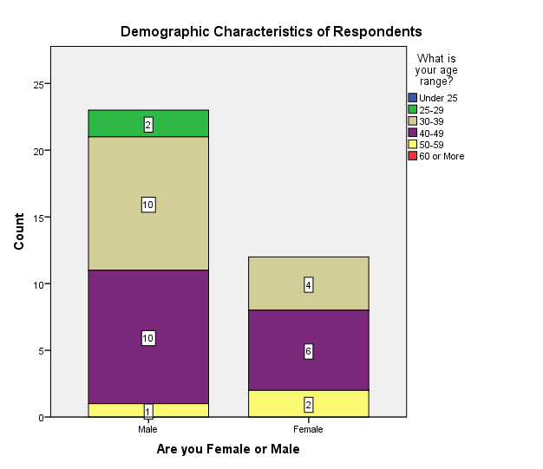
Figure 1: Demographic characteristics of respondents
Count
 |  | What academic qualification or teacher training certificate do you have? |  |  | Total
 |  | Mathematics | Education | Mathematics Education | Total
What is your age range? | 25-29 | 1 | 0 | 1 | 2
What is your age range? | 30-39 | 8 | 1 | 5 | 14
What is your age range? | 40-49 | 1 | 0 | 15 | 16
What is your age range? | 50-59 | 0 | 0 | 3 | 3
Total |  | 10 | 1 | 24 | 35
Table 1: Age Range and Qualification Crosstab
 | Value | df | Asymptotic Significance (2-sided)
Pearson Chi-Square | 13.685ª | 6 | .033
Likelihood Ratio | 15.494 | 6 | .017
Linear-by-Linear Association | 9.283 | 1 | .002
N of Valid Cases | 35
- 10 cells (83.3%) have expected count less than 5. The minimum expected count is .06.

Table 2: Gender variation among respondents
Chi Square Test; The Chi-Square Test function tabulates a variable into categories and computes a chi-square Statistic to determine whether there is a relationship between two categorical, nominal Variables. This goodness-of-fit test compares the observed and expected frequencies in each category to test that all categories contain the same proportion of values or test that each category contains a user-specified proportion of values.

Note: If the Pearson Chi-Square (probability of the chi-square test statistic) value is more than alpha level of significance of 0.05 (when the confidence level is set to 95%), it indicates that the two Variables do not have any relationship and the Null Hypothesis is not rejected.
Though the representation of female and male shows a slight lower participation of women in the study it might as well indicate differences in motivation to participate or other factors that cannot be established by this study. The age of the respondents was fairly evenly distributed. These descriptive data reflected the demographic structures and general profile of Botswana mathematics teachers in senior secondary schools, showing that a majority of teachers were 59 years and below.
How consistent are the aims and objectives of the mathematics syllabus with the specific objectives in the syllabus (critique of the syllabus)?

Statistics
 |  | student supervision(other than teaching) | student project supervision | what academic qualification or teacher training certificate do you have | do you use a textbook in teaching mathematics to your class | what subject matter do you emphasize in your mathematics class
N | Valid | 35 | 35 | 35 | 34 | 33
N | Missing | 0 | 0 | 0 | 1 | 2
Table 3: Frequencies on how respondents answered questions
This Function provides statistics and graphical displays that were used for describing many types of variables. Table 3 shows a sample on how teachers were attempting the questionnaire and variables left not attempted.
 |  | Frequency | Percent | Valid Percent | Cumulative Percent
Valid |  | 2 | 5.7 | 5.7 | 5.7
Valid | 0 Hour/Period | 25 | 71.4 | 71.4 | 77.1
Valid | 1 Hour/Period | 5 | 14.3 | 14.3 | 91.4
Valid | 2 Hour/Period | 2 | 5.7 | 5.7 | 97.1
Valid | 5 Hour/period | 1 | 2.9 | 2.9 | 100.0
Valid | Total | 35 | 100.0 | 100.0
Table 4: Teachers-Student project supervision
The above description suggests that the majority of mathematics teachers engage less or never in student project supervision as advocated for by the mathematics curriculum in support of learner-centred model.
 |  | Frequency | Percent | Valid Percent | Cumulative Percent
Valid | Mathematics | 10 | 28.6 | 28.6 | 28.6
Valid | Education | 1 | 2.9 | 2.9 | 31.4
Valid | Mathematics Education | 24 | 68.6 | 68.6 | 100.0
Valid | Total | 35 | 100.0 | 100.0
Table 5: Teachers academic qualifications
The distribution reveals a good quality of teachers despite misappropriation of low results in senior secondary school vis-à-vis the goals of the mathematics curriculum.
An interview was used to facilitate some gaps in the information on teacher development for triangulation reasons to dig deep on grey areas.
What professional development plan and support system was put in place to help teachers cope with the espoused postmodernist pedagogical approach to the BGCSE mathematics syllabus?
Interview: According to five (5) respondents,
“In-service training which at the moment is left to schools. Curriculum unit used to assist and even University of Botswana Mathematics and Science Education but currently there is no support system”.

Three (3) respondents stated that, there is little Continuing Professional Development (CPD) for teachers especially new teachers joining the system.
The above information reveals that a lot needs to be done in the form of professional uplifting and development to empower teachers in various areas during teaching.

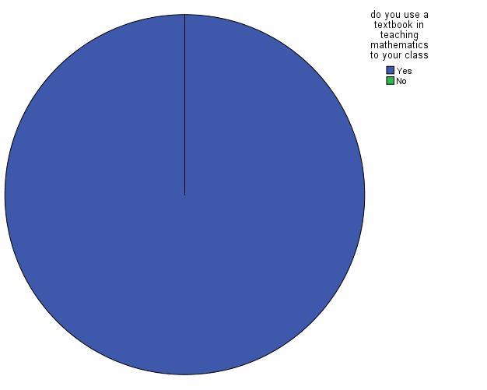
Figure 2: The use of text books in mathematic class
The majority of teachers, according to the chart, use text books when teaching mathematics. This suggests that teachers rarely deviate from textbook to pursue ideas that students bring up during class discussions which may limit learner’s independent thinking.
what subject matter do you emphasize in your mathematics class |  | Frequency | Percent | Valid Percent | Cumulative Percent
Valid | Mainly number (e.g. whole numbers, fractions, decimals, percentages etc) | 1 | 2.9 | 3.0 | 3.0
Valid | Algebra | 6 | 17.1 | 18.2 | 21.2
Valid | combined algebra and geometry | 2 | 5.7 | 6.1 | 27.3
Valid | combined algebra, geometry,number etc | 9 | 25.7 | 27.3 | 54.5
Valid | all of them | 15 | 42.9 | 45.5 | 100.0
Valid | Total | 33 | 94.3 | 100.0
Missing | System | 2 | 5.7
Total |  | 35 | 100.0
Table 6: Topics emphasized in class
An uneven distribution is reflected in the above frequencies with only 45.5% emphasizing all areas of mathematics while teaching. This alone leaves a lot to be desired when considering the poor results but other variables beyond the scope of this study may be involved.
How has the BGCSE mathematics syllabus been operationalized in the classroom?
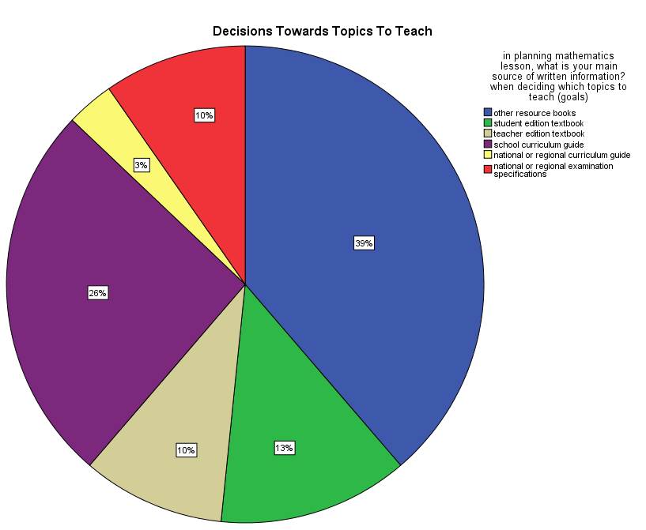
Figure 3: Decision towards topic to teach
The pie chart shows that 26% is reserved for the curriculum during teaching, while the remaining is on other sources which can be termed supporting documents. The curriculum is hoped to act as a guide in any context. We witness a larger portion of decisions being determined by text books which in most cases are said to not be aligned to the curriculum as observed by other respondents. This in the researcher’s view contributes to low performance since examinations are developed according to the curriculum and not text books.
In planning mathematics lesson, what is your main source of written information? When selecting problems and exercises for work in class and homework
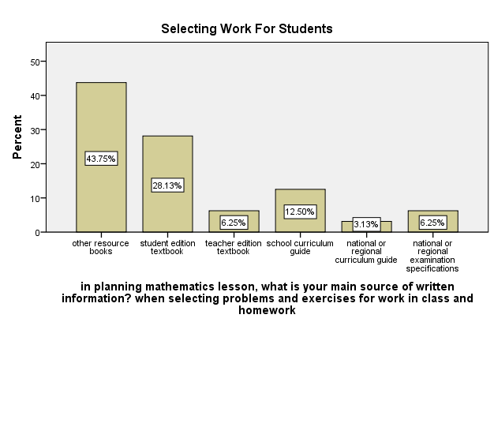
Figure 4: Selecting work for students
The curriculum in any setting acts as a guide, but Figure 4 above suggests it carries a low influence in selection of what to be taught in class and how it should be taught. Teachers seem not to use the curriculum when planning work for students yet the curriculum has specifications in a form of goals and vision towards a child-centered class. The main aim of the syllabus is to assess positive achievements at all levels and candidates should be assessed in ways that encourage them to show what they know, understand and can do. This can only be achieved by following the syllabus as the guide in order to improve relevance and performance in mathematics. One may conclude that teachers don’t use the syllabus as their guide though the examinations and goals are drawn from the syllabus, hence poor performance.
In a typical month of lessons for your mathematics class, what percentage of time is spent on lecture style presentation by teacher?
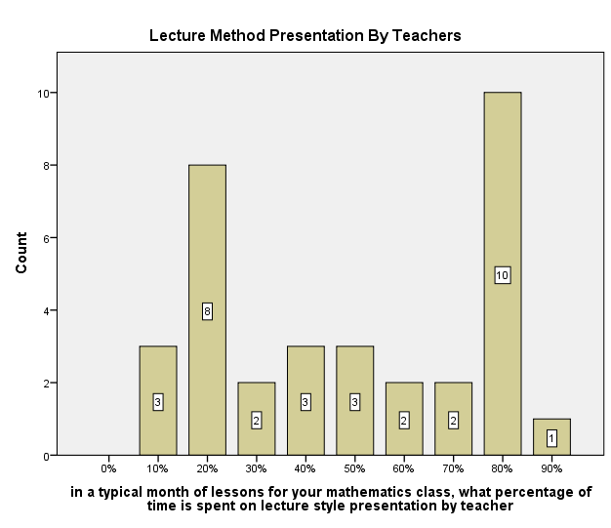
Figure 5: Time spent on lecture method
A majority of teachers spent over 50% of their time on lecture methods contrary to the aims and objectives of the curriculum which states that learners should develop abilities to solve problems, model and describe varieties of practical life situations, present the solution clearly, check and interpret the results. This would promote the ability to produce and appreciate imaginative and creative work arising from mathematical ideas; willingness and abilities to work independently and cooperatively.

Time spent on Teacher Guided Student Practice
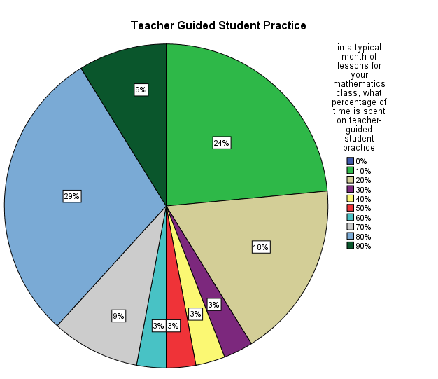
Figure 6: Teacher's guided practices in class
A majority of (63%) spent 30% and below of their time on teacher guided learner practice which clearly reveals a low learner-centered practice in mathematics. It gives the researcher reasons to assume and conclude that lack of learner-centered model of teaching contributes to poor performance in mathematics at senior secondary school.
 |  | Frequency | Percent | Valid Percent | Cumulative Percent
Valid | None | 5 | 14.3 | 14.3 | 14.3
Valid | Less than 1 Hour | 6 | 17.1 | 17.1 | 31.4
Valid | 1-2 Hours | 23 | 65.7 | 65.7 | 97.1
Valid | More than 4 Hours | 1 | 2.9 | 2.9 | 100.0
Valid | Total | 35 | 100.0 | 100.0
Table 7: Preparing teaching approach for the next day
About 66% teachers prepared 1-2 hours for the next day, 17% prepared for less than 1 hour, and 14% did not prepare at all. Fewer teachers (2.9%) are preparing for more than 4 hours. This suggests that teachers still go to class without planning the teaching approach which can significantly impact on students’ performance.
How have the new ideas presented in the syllabus been perceived by teachers?
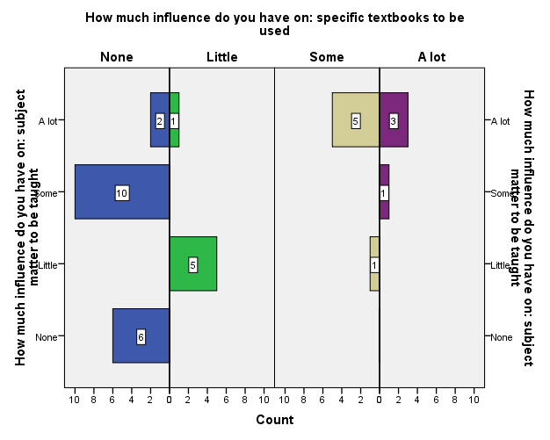
Table 8: Teachers’ influences on mathematics learning materials and subject matter
This distribution shows the influence portrayed by teachers on the selection of text books and subject matter to be taught. It reveals teachers have little or no influence in the selection of what to be taught and the text books used in mathematics. Teachers are believed to have enough information on what is to be taught and the materials to be used, hence they should participate as major stakeholders in prescriptions of materials and subject matter.
What are the reactions of students to the existing teaching methodologies?
Descriptive Statistics
 | N | Minimum | Maximum | Mean | Std. Deviation
In your mathematics lesson how often do you explain the reasoning behind an idea | 32 | 2 | 4 | 3.16 | .808
In your mathematics lesson how often do you represent and analyze relationships using tables, charts or graphs | 33 | 1 | 4 | 2.91 | .914
In your mathematics lesson how often do you work on problems for which there is no immediately obvious method of solution | 33 | 1 | 4 | 2.64 | 1.084
In your mathematics lesson how often do you use method to solve exercises | 32 | 1 | 4 | 2.44 | 1.243
Valid N (listwise) | 31
Table 9: Learners reactions on teaching methods
For the variable student involvement 31 participants managed to attempt to the question. On average the table shows that some teachers never involve learners to reason behind an idea, analyze relationships, work problems without immediate solutions and use project method. Having this manifestation mathematics performance will always be at risk.
Dependent Variable: performance
Model |  | Unstandardized Coefficients |  | t | Sig.
 |  | B | Std. Error | t | Sig.
1 | (Constant) | 35.377 | 2.998 | 11.800 | .000
1 | learner_centred | .094 | .045 | 2.078 | .046
Table 10: Testing for hypothesis with simple linear model
By the rule of thumb the t-statistics is greater than 2 which implies that the learner-centered is statically significant in explaining the performance for learners. However for any change brought in learner-centered the performance will increase by 9%. Therefore, provided n is sufficiently large, we would expect the mean of z to be large and positive if β1 > β0 and large and negative if β1 < β0. Thus we will reject the null hypothesis whenever z is sufficiently far from 0.
ANOVA
Model |  | Sum of Squares | df | Mean Square | F | Sig.
1 | Regression | 76.423 | 1 | 76.423 | 4.317 | .046^{b}
1 | Residual | 584.148 | 33 | 17.701
1 | Total | 660.571 | 34
Table 11: Testing for significance in variables
If the probability of F-statistic is significant this implies that the explanatory variables are jointly significant in explaining the overall performance of the model. The statistical data in Table 11 suggests that lack or poor implementation of learner-centered method contributes to poor performance in mathematics.
Interview Data
Development of the BGCSE syllabus
62.5% of 8 (eight) respondents confirmed that the syllabus was designed to child or learner centred and assess positive achievements which they attested is not happening at schools. 12.5% of 8 (eight) respondents reported that the syllabus advocates for real life situation learning which provides a wide range of learner centred activities. Lastly 25% of 8 (eight) the respondents stated that the syllabus should meet the global requirements and should also prepare learners for the world of work.
Consistency between the aims/goals and objectives of the mathematics curriculum
Concerning the alignment of class objectives and aims of the curriculum all respondents confirmed a significant relationship between the two.
Operationalisation of the BGCSE mathematics curriculum
12.5% of 8 (eight) respondents revealed that they advocate for the use of various teaching methods in order to improve results. The remaining 87.5% of 8 (eight) respondents said it is impossible to use the child/learner-centred model of teaching because of lack of resources both human and physical. They also suggested that it is difficult to use the learner-centred method given the number of learners they have in class versus time. The respondents emphasised that learner centred model of teaching is not applicable in the concept of teaching looking at the current educations requirements and testing.
Teacher’s perceptions on new innovations in the syllabus
37.5% of 8 (eight) reflected that they accepted the changes and new components of the syllabus but found it very difficult to put them into practice. Respondents stated that the learner centred model requires a lot of resources and skills for it to be implemented effectively. They suggested continuous in-service training in order to equip all stakeholders with relevant skills and knowledge. 62.5% of 8 (eight) revealed that the new components caused a lot of congestion which doesn’t allow application during teaching and learning. Teachers are not able to employ learner centred model which contributes to low or poor performance in BGCSE mathematics.
Learner’s reactions to the methods of teaching
87.5% of 8 (eight) respondents revealed that learners view teacher-centred as a cumbersome practice. Learners are not empowered to be independent learners they rely on rote learning which only prepares them for examinations. Respondents also reflected that this style of learning is at times not guided by the curriculum but by other resources like text books which later contribute to poor performance because examinations are informed by the curriculum. Only 12.5% of 8 (eight) revealed that learners progress well through learner-centred methods of teaching, since they get the chance of manipulating their ideas and also explore abilities in different contexts.
Impact of in-service training on learner centred method
25% of 8 (eight) respondents revealed that nothing has been done as far as in-service is concerned, they stated that if availed it can be of help and improve performance. 12.5% of 8 (eight) respondents stated that they have given up on learner centred and only rely on teacher centred because of the congested curriculum. Lastly 62.5% of 8 (eight) respondents’ alluded that the in-service training is rarely done and if given priority it could bear fruits and improve performance in mathematics. Most teachers believe learner-centred method is necessary and can improve results.
How has the compartmentalisation of the syllabus into ‘core’ and ‘extended’ parts impacted on the implementation process?
In assessing the work of the students in your mathematics class, how much weight do you standardise test produced outside the school?
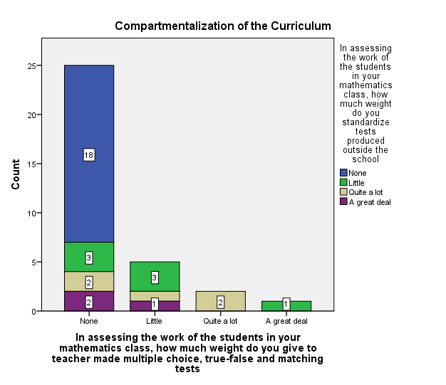
Table 12: Compartmentalization of the curriculum
The above graph reveals how compartments during school examinations are organized. Very little is adopted from the national testing system or the curriculum. This reflects that learners are not trained according to what they get during the BGCSE in mathematics. This is one of the contributing factors since the structure of examination and testing is inconsistent.
The chapter presented research findings for both questionnaire and interview data. The chapter also included a summary of the demographic characteristics of respondents. The chi-square analysis helped to provide the relationship among the demographic variables. The chapter revealed and summarized the interview data and questionnaire suggesting lack of learner-centered method to be a contributing factor in poor students’ performance in mathematics in the BGCSE programme.

SUMMARY, CONCLUSIONS, RECOMMENDATIONS AND IMPLICATIONS

Introduction
This chapter provides a general overview of the study. It presents conclusions that can be drawn from the research findings of the study. The latter contributory part of the chapter offers suggestions for further research and policy direction on curriculum implementation concerning the BGCSE mathematics.

Overview of the study
This study was carried out within the Botswana context to find out, to what extent the envisaged classroom implementation process of the BGCSE mathematics syllabus had been achieved considering its postmodernist (social constructivist) methodological rhetoric. The study has unravelled the reality of poor curriculum implementation as a contributing factor to poor BGCSE mathematics results. The BGCSE mathematics curriculum prescribes learner-centred methods to be vital and necessary in mathematics instruction, with a recognition that learners learn more through discovery and exploratory modes. The following questions were addressed:
- How consistent are the aims and objectives of the mathematics syllabus with the specific objectives in the syllabus (critique of the syllabus)?
- What professional development plan and support system was put in place to help teachers cope with the espoused postmodernist pedagogical approach to the BGCSE mathematics syllabus?
- How has the BGCSE mathematics syllabus been operationalized in the classroom?
- How have the new ideas presented in the syllabus been perceived by teachers?
- What are the reactions of students to the existing teaching methodologies?
- How has in-service training impacted on the implementation of the learner-centred teaching methodologies?
- How has the compartmentalisation of the syllabus into ‘core’ and ‘extended’ parts impacted on the implementation process?
Methodology
A nationwide sample around senior secondary school mathematics teachers were interviewed and completed a questionnaire. The questionnaire comprised of demographic and professional background. It also consisted of experiences and general questions on curriculum implementation with particular reference to learner’s centred method.
Data Analysis
The researcher coded and entered data, analysis were done using the Statistical Package for Social Sciences (SPSS-X) in University of Botswana. The analysis of data included descriptive statistics, chi-square analysis and Simple linear model (ordinary least square) for testing the statistical significance. The interview data was analyzed according to relative content with each question treated separately.
Descriptive statistics assisted in describing the demographic characteristics, teacher’s views on the implementation of mathematics curriculum. The Simple linear model was used to test the significance level between the independent variable and the causal factor which in this aspect is learner-centered method. The data revealed a great impact caused by lack of use of the learner- centered methods in mathematics which leads to poor performance in BGCSE.

Consideration of findings in the light of the theoretical framework
As outlined in Chapter One this study adopted a Goodlad, Klein and Tyle (1979) theoretical framework and used a typology of curricular representations to conceptually underpin the framework. This theoretical framework includes:
- ideal or intended curriculum (original ideas of the designers)
- formal curriculum (documents, materials)
- perceived curriculum (especially by the teachers)
- operational (actual instructional process in classroom)
- experiential (reaction and outcomes of the learners)
The above framework has been fulfilled by the study and also guided towards getting the appropriate results. The findings revealed that formal documents are not aligned with curriculum and the actual operations in the classroom is somewhat farfetched. Also through teachers input the study theoretical frame work revealed the experiential reactions of learners in a mathematics class. This is a clear critique of the system of learning based on scrutinising documents and actual operations in the classroom.

Implementation of the learner-centred BGCSE mathematics syllabus and student performance thereof
The research hypothesis of the study stated that “There is significant difference between the implementation of the learner-centred BGCSE mathematics syllabus and student performance”, by the rule of thumb the t-statistics was found to be greater than 2 which implies that the learner-centered methodology is statically significant in explaining the performance for learners. However for any change brought in learner-centered the performance will increase by 9%.
The null hypothesis which stated “There is no significant difference between the implementation of the learner-centred BGCSE mathematics syllabus and student performance thereof”. Based on the regression coefficient it gives a measure of how much the dependent variable is a function of change in an independent variable. The regression coefficient gives the change in the dependent variable per unit change in the independent variable. Hence, one can use the regression coefficient to calculate the expended change in a response by, saying the performance is anticipating a 9% increase according to the regression assessment.

Summary of the research findings
Though the study was not focused on establishing any conclusion through demographic characteristics of respondents more especially gender, revealed an unmotivated participation in the study. The findings also revealed age 59 and below to be prevalent among mathematics teachers in senior secondary schools in Botswana. The majority of these mathematics teachers seem to hold a Bachelors’ Degree in mathematics education. The chi-square procedure reflected a relationship between demographic variables. The findings of the study suggests that curriculum implementation contributes to poor performance in mathematics largely owing to lack of support (both resources and teacher professional development) for learner-centered methods as stated in the BGCSE Mathematics curriculum.

Implication of these findings
The implications of this study are discussed under three headings; namely implications on theory, implications on policy formulations and implementation and implication on research.
Implication on theory
The theory allowed the researcher to critique the implementation of the mathematics curriculum. There was a careful study of curricular representations with the aim of building detailed information on the implementation process.
Implication on Policy
The findings suggest that policy makers should always engage stakeholders when formulating policies and when introducing new components into the curriculum. Government through its structures and subsidiaries should play a crucial role in protecting education.
Implication for research
It was revealed in chapter two that similar studies were done in science education but these findings have reflected a need for similar studies in mathematics education.

Conclusions

This study was set to find out, the extent to which the envisaged classroom implementation process of the BGCSE mathematics syllabus has been achieved considering its postmodernist (social constructivist) methodological rhetoric, it was also guided by the following general objectives:
- To assess the implementation of the learner-centred methods on BGCSE mathematics syllabus and establish the impact of BGCSE mathematics syllabus implementation on educational outcomes.
- To explore teachers experiences on BGCSE curriculum implementation and assess new ideas presented in the syllabus as perceived by teachers.
- Critique the aims and objectives of the mathematics syllabus with the specific objectives in the syllabus and establish professional development plan and support system was put in place to help teachers cope with the espoused postmodernist pedagogical approach to the BGCSE mathematics syllabus.
- To assess how has the BGCSE mathematics syllabus been operationalized in the classroom and establish how the new ideas presented in the syllabus been perceived by teachers.
- To examine the reactions of students to the existing teaching methodologies and examine how the compartmentalisation of the syllabus into ‘core’ and ‘extended’ parts impacted on the implementation process.
The main conclusion drawn from these findings is that lack of learner centred model of teaching mathematics contributes to poor performance in mathematics education. At this stage the study cannot robustly suggest policy recommendations though conclusions and recommendations can be drawn from the study. All the above objectives have been fulfilled and revealed by the findings. It is then evident that mathematics curriculum implementation of BGCSE need a lot of improvement since it contributes significantly to poor results.

Recommendations

The significance of this study could benefit all stakeholders since the study reveals a relationship between variables as causal and independent as expected by the researcher. Based on the findings of the study, the following recommendations could be drawn for consideration:
- Comprehensive in-service training in the form of continuous professional development concerning learner centred methods should be conducted.
- Policy makers should consult and engage teachers as stakeholders when bringing changes to the curriculum.
- Guideline for learner centred method and testing should be proposed for compliance during teaching.

REFERENCES

Adamu, A. (1989) Rhetoric and reality in Nigerian science education: Observations of science teaching in Kano State secondary schools. International Journal of Educational Development. 9(4), 251-262.
Anderson, J. (2009). Mathematics curriculum development and the role of problem-solving. ACSAConference 2009. Sydney: The University of Sydney.
Botswana, Republic of (1991) National Development Plan 7: 1991-1997. Gaborone: Government Printer.
Botswana, Republic of (1994) Government Paper No. 2 of 1994: The Revised National Policy on Education. Gaborone: Government Printer.
Botswana, Republic of (1993) Report of the National Commission on Education, 1993. Gaborone: Government Printer.
Botswana, Republic of (1976a) Report of the National Commission on Education: Education for Kagisano. Volume 1. Gaborone: Government Printer.
Botswana, Republic of (1976b) Report of the National Commission on Education: Education for Kagisano. Volume 2: Annexes. Gaborone: Government Printer.
Botswana, Republic of (1997) National Development Plan 8: 1997/8-2002/3. Gaborone: Government Printer.
Bruner, J. (1996). The culture of education. Cambridge, MA: Harvard University press.
Brito, M. (1996). Um estudo sobre as attitudes em relacao a matematica em estudantes de 1 e2 graus(Astudy about attitudes towards mathematics on elementary and secondary schools) tese de livre docencia, campinus, SP UNICAMPwards.
Creswell, J. W. (2013). Research design: Qualitative, quantitative, and mixed methods approaches: Sage publications.
Cowan’s, m. (2010). Evidence of a spiral curriculum using mathematical problem-solving tool. Interactivelearning environments, 6(3), 205-224.
Cowan, p., Morrison, H., & Mcbride, F. (2010). Evidence of spiral curriculum using mathematical problem-solving tool. Interactive Learning Environments, 6(3), 205-224.
Collins, H. (2010). Creative Research: The theory and practice of research for the
Das, R., & Das, G. (2013). Math anxiety: poor problem-solving factor in school mathematics. International Journal Scientific and Research Publication. 3(4), 1-5.
de Feiter, L., Vonk, H. & Van den Akker, J. (1995) Towards more Effective Science Teacher Development in Southern Africa. Amsterdam: VU University Press.
Fuller, B. & Clarke, (1994) Raising school effects while ignoring culture? Local conditions and the influence of classroom tool, rules and pedagogy. Review of Educational Research. 64(1), 119-157.
Fennema, E. (1989). The study of affect and mathematics: A proposed generic model for research. In I. D. (Eds.), Affect and Mathematical problem-solving (pp. 205-219). New York: Springer-Verlag.
Educational Psychology: An International Journal of Experimental Educational Psychology, 20(2),237-243...
creative industries. AVA Publications.
Goodlad, J. Klein, M. & Tyle, K. (1979) The domains of curriculum and their study. In J. Goodlad et al (Eds.) Curriculum Inquiry: The Study of Curriculum Practice. New York: McGraw-Hill. Pp.43-76.
Guthrie, G. (1990) To the defence of traditional teaching in lesser-developed countries. In V. Rust & P. Dalin (Eds.) Teachers and Teaching in the Developing World. New York: Garland Publishing.
Lockheed, M. (1993) The condition of primary education in developing countries. In H. Levin & M. Lockheed (Eds.) Effective Schools in Developing Countries. London: Falmer Press.
Marope, P.T.M. (with Amey, A.A.K.) (1995) Basic Education Consolidation (BEC) Project Impact and Basic Education Teacher Effectiveness Study. Gaborone: BEC Project/AED.
MEC (1993) Report on the Monitoring of the Secondary Level Reform process. Grade 9, 1992. Windhoek: Ministry of Education and Culture.
Mkandawire, D.S. (1993) Teacher effectiveness in Namibian schools. In K.K. Prah (Ed.) Social Science Research Priorities for Namibia. Windhoek, University of Namibia/Council for the Development of Economic and Social research in Africa.
MEC (1992) Monitoring the Grade 8 Reform (September-October 1991). Windhoek: Ministry of Education and Culture.
Mok I.A.C., &. M. (2001). The metamorphosis of the 'Virtuoso':Pegagogic patterns in Hong Kong primary Mathematics classroom. Teaching and Teacher Education , 17(4), 455-468.
Mok, I. A., Cai, J., & Fung, A. (2005). Teaching mathematics through problem-solving: Struggles a Hong Kong teacher faces. Paper presented at Earcome3 conference: Shanghai, China.
Mok, I. A.-R. (2006). A tale of two cities: a comparison of six teachers in Hong Kong and Shanghai. Shanghai: Rotterdam: Sense Publishers.
Novotna, J., Eisenmann, P., Pribyl, J., Ondrusova, J., & Brehovsky, J. (2014). Journal of efficiency and responsibility inEducation and science, 7(1), 1-6. doi:10.7160/eriesj.2013.070101
Pearson, J. (1987). Interrelationships between gender and communication. Ohio State
University, College of Education, Center for Sex Equity, Instructional Materials
Laboratory, 3:2-8.
Prophet, R. (1995) Views from the Botswana junior secondary classroom: Case study of a curriculum intervention. International Journal of Educational Development. 15(2), 127-140.
Prophet, R. (1993) Coping and control: Science teaching strategies in Botswana. International Journal of Qualitative Studies in Education. 6(3), 197-209.
Prophet, R. & Rowell, P. (1990) The curriculum observed. In C.W. Snyder and P.T. Ramatsui (Eds.) Curriculum in the Classroom. Macmillan: Gaborone.
Tabulawa, R. (2002) Geography students as constructors of classroom knowledge and practice: A case study from Botswana. Journal of curriculum Studies. 35(1) 1-21.
Tabulawa, R. (1998) Teachers’ perspectives on classroom practice in Botswana: Implications for pedagogical change. International journal of Qualitative studies in Education. 11(2), 249-268.
Tabulawa, R. (1997) Pedagogical classroom practice and the social context: The case of Botswana. International Journal of Educational Development. 17(2), 189-204.
Tabulawa, R. (1996) Student perceptions of teaching and learning patterns in geography: A Botswana senior secondary school case study. Mosenodi: Journal of the Botswana Educational Research Association. 4(1), 31-46.
The National Commission on Education (NCE) (1977). Republic of Botswana,
Gaborone: Government Press.
Mathematics attitudes and affect. Psychology of Women Quarterly, 14(3), 299-324.
Qualitative Comparative Analysis (QCA).(2002). Standards at key stage 1: English and Mathematics . London: QCA.
Sepeng, S. (2014). Mathematical reasoning and common-sense in word problem-solving. 7(3), 755-763.
Utsumi, C., & Mendes, R. (2010). Researching the attitudes towards mathematics in basic education.
Yandila, C.D. et al (2004) Improvement of senior secondary school physics syllabuses in Botswana. Proceedings of the XIth Symposium of the International Organisation for Science and Technology Education, 25-30 July 2004, Lublin, Poland. pp. 147-148.

